**Class Project 5**

Use two images for each operation to do the following operations and write down their advantages and disadvantages and explain your results:

1. **2D DFT (lena):**

**Algorithm:**

Function of 2D DFT:

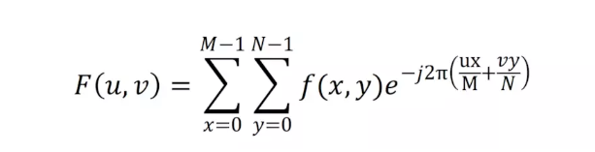

Function of 2D IDFT:

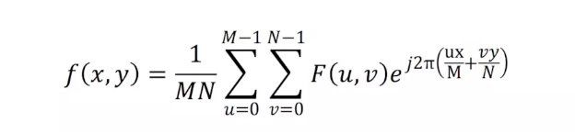

Let R(u,v) and I(u,c) denote the real and imaginary parts of F(u,v), respectively

The amplitude spectrum is:

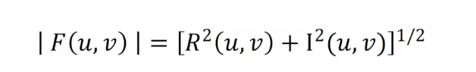

The phase spectrum is:

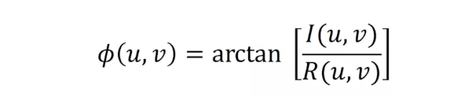

**Results (including pictures):**

Result of processing “Lena.pgm”:

Source Image: Result after 2D DFT (real part):

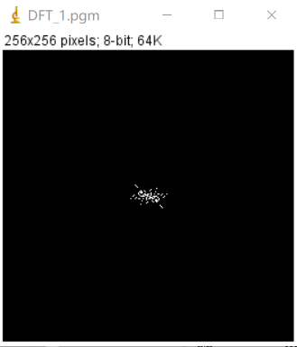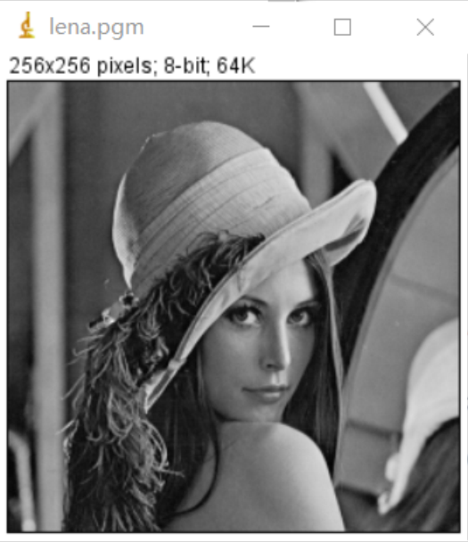

Result after 2D DFT (im part)

Result after 2D DFT (combine):

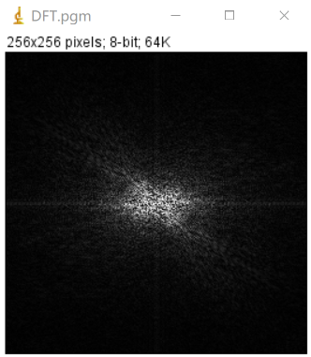 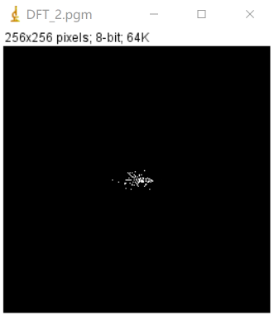

**Discussion:**

Since the image is usually smooth, most images can be represented by a small number of DFT coefficients, and all other higher coefficients can be almost ignored or zero. Therefore, DFT is very useful for image compression, especially for sparse Fourier images. Only a few Fourier coefficients are used to reconstruct the image, so only these frequencies can be stored, the others can be discarded.

**Codes:**

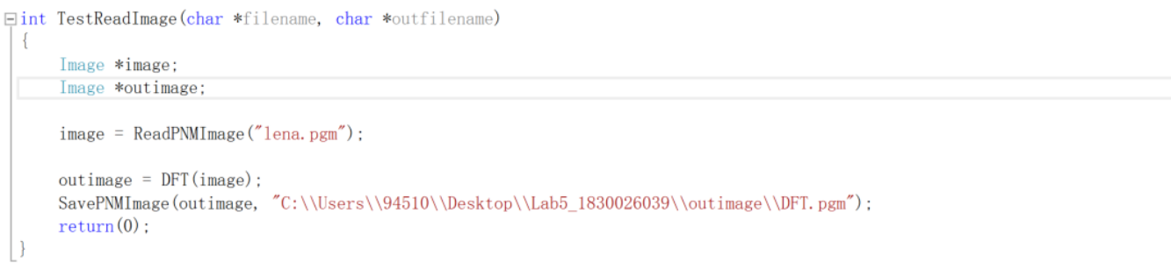

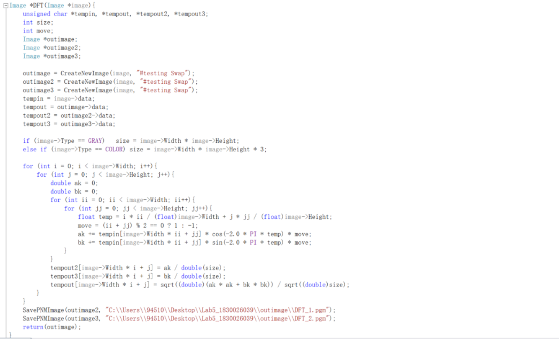

1. **Phase angle reconstruct(lena):**

**Algorithm:**

Phase angle is:



After the above Fourier transform, it is easy to get the phase spectrum and amplitude spectrum of the image. At this time, the Fourier spectrum of the image is . Let , get the phase spectrum of the image. Finally, use Euler’s formula to get: .

**Results (including pictures):**

Result of processing “Lena.pgm”:

Source Image: Result after Gamma correction:

(1.0)

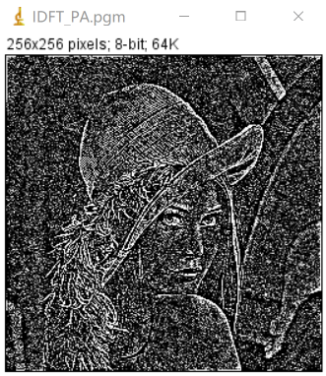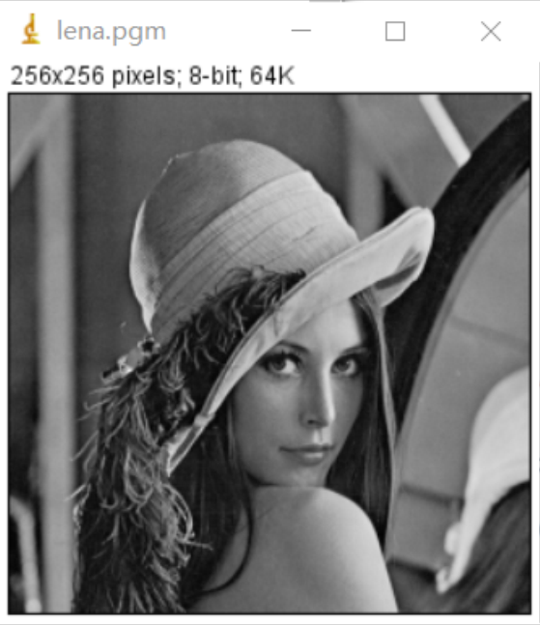

**Discussion:**

The contour information of the image is well reconstructed by using the phase spectrum, so it is easy to verify that the phase spectrum of the image stores the position information of the image. However, due to the lack of amplitude spectrum, the reconstructed image lacks changes in pixel values.

**Codes:**

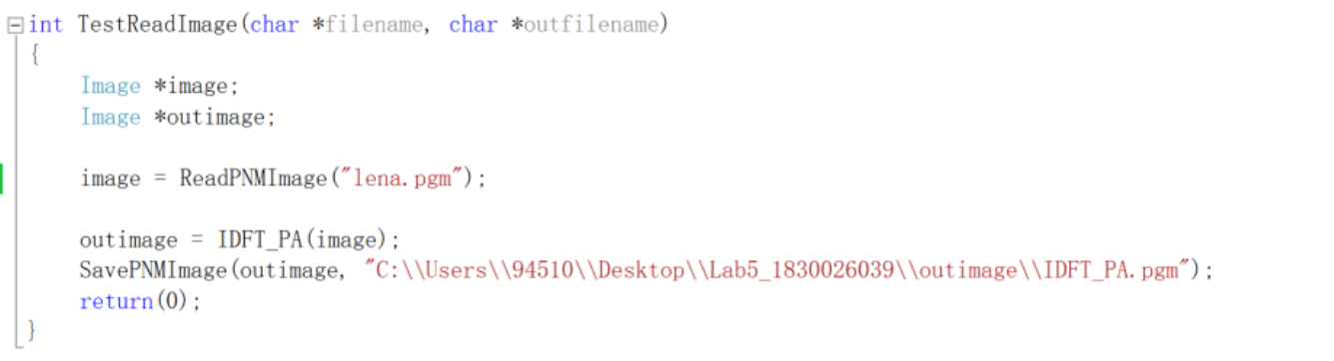

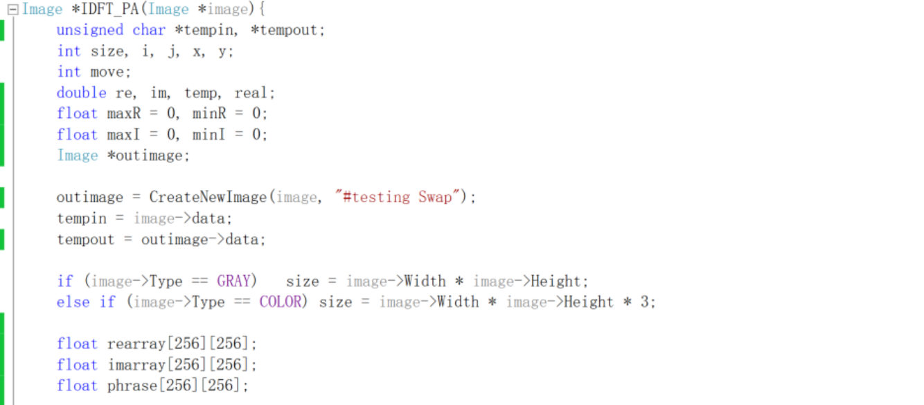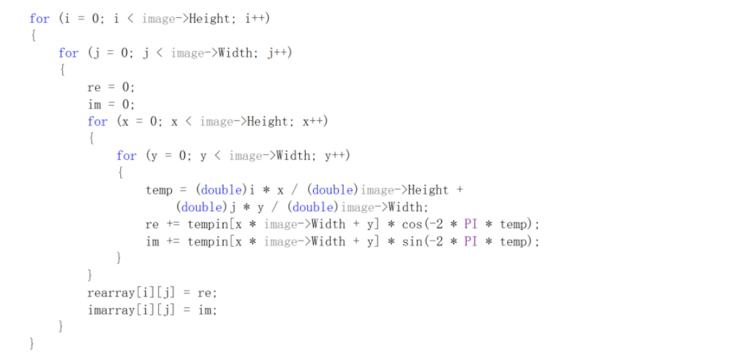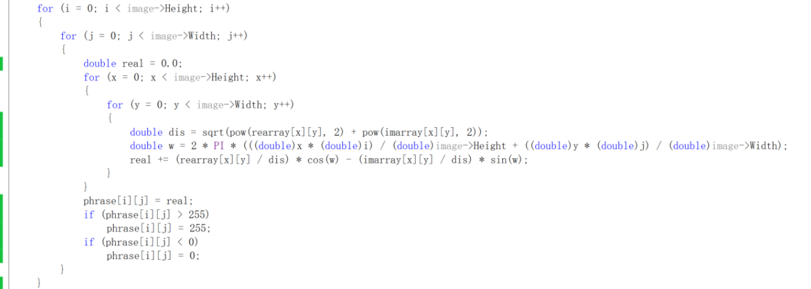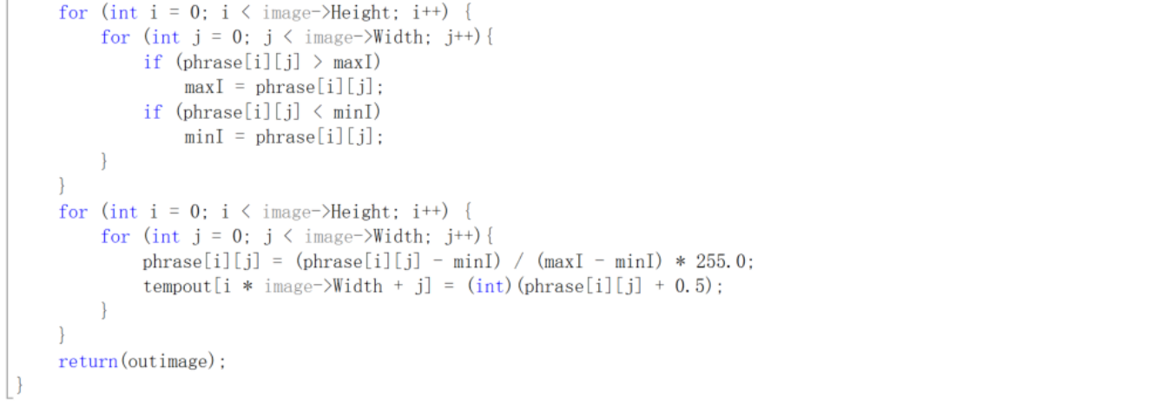

1. **Magnitude reconstruct (lena):**

**Algorism**

The amplitude spectrum is:



Let the phase spectrum in the Fourier spectrum of the image be equal to 0, and obtain the amplitude spectrum , Then the amplitude spectrum is subjected to Fourier transform to reconstruct the image.

**Results (including pictures):**

Result of processing “Lena.pgm”:

Source Image: Result after magnitude reconstruct:

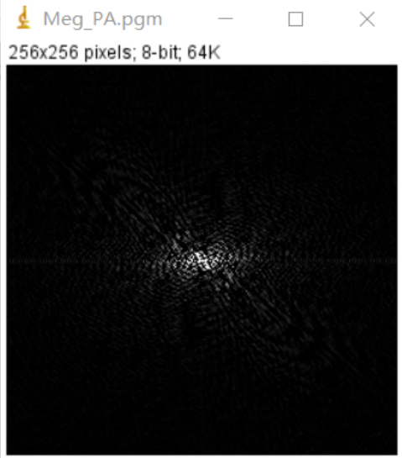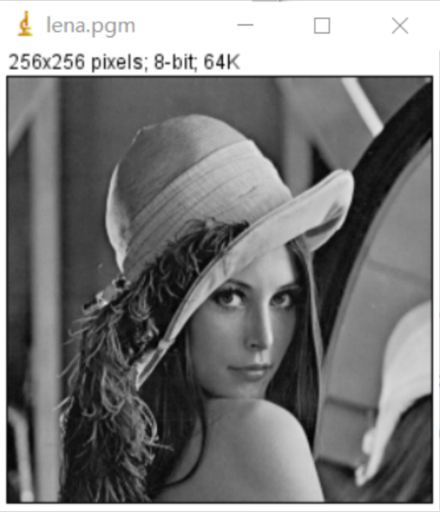

**Discussion:**

The original image cannot be reconstructed from the amplitude spectrum, which also verifies that the amplitude spectrum only contains the gray information of the image, and the phase spectrum of the image plays a decisive role in the content of the image.

**Codes:**

